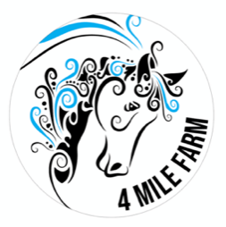
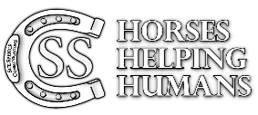
Horses Helping Humans
Price List- July 2020

Workshop | Time | Cost plus GST
3 Week Private Course  (1:1) Up to 3 students | 1-1.5 hours | $165 per session, per person  $495 per program, per person
Half day Family Dynamics Workshop  Up to 4 people | 3 hours | POA
Half day Family Dynamics Workshop  Up to 6 people | 3 hours | POA
Half day youth Workshop  Up to 4 people  Additional participants $100p/p | 3 hours | POA
Half day Adult Community service staff/team dynamic workshop. | 3 hours | POA
All day Corporate Business Workshop up to 10 people | 6 hours | POA
Private Adult Consultation | 1-1.5 hours | POA
NDIS 1:1  Once off session | 1 hour | $180 no gst
NDIS 1:1 on going sessions  (more than one session) | 1 hour | $165 no gst
Follow up reports- Private  NDIS Reports |  | $100  $165 no gst

